- Time series analysis techniques
Random forest
Goal: predict next reading based on historic data
The model tracks the general upward trend well from April through early September — the orange (predicted) closely follows the blue (actual) during this period. That's a good sign for the middle of the test window.
From mid-September onward, the predicted line flatlines around 14,000–15,000 while the actual signal keeps climbing to 17,000–18,000 and becomes increasingly volatile. This is a classic Random Forest extrapolation failure — RF cannot predict values outside the range it was trained on.
There are two sudden drops in the actual signal — one around early August (down to ~3,500) and one around late September/early October (down to ~10,000). The model misses both of them almost entirely. These are almost certainly real anomalies — sensor faults, lock operations, or measurement errors on the canal
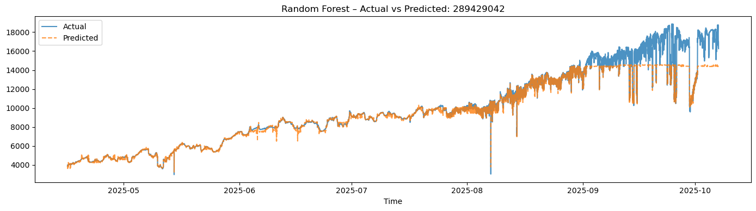
Support Vector Regression (SVR)
Goal: predict the readings of a particular sensor based on neighboring sensor data in case a sensor goes down.
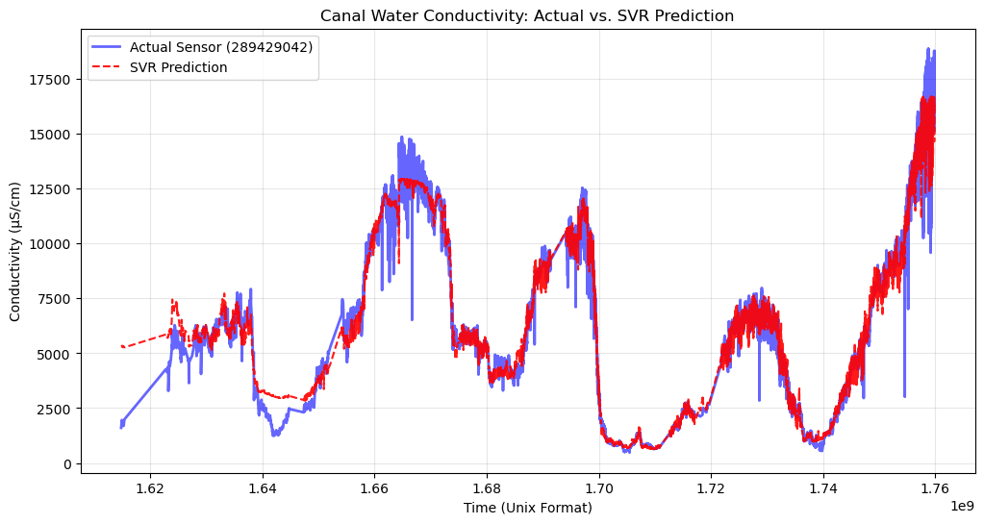
The red SVR prediction tracks the blue actual signal closely across most of the time range, capturing the major oscillatory patterns in canal conductivity.
The actual sensor shows rapid, jagged fluctuations that the SVR smooths over. This is expected behavior as it acts as a natural low-pass filter.
There's a notable divergence at the start, where the prediction begins higher than the actual values. This could suggest the model is influenced by the other sensors which may have already been elevated at that time.
At the very end, SVR undershoots slightly, which is typical since SVR with epsilon-insensitive loss tends to underestimate extremes.
Gradient boosting algorithms

Matrix Profile
There's a clear long-term seasonal pattern, conductivity peaks in summer/autumn and drops in winter, repeating annually. This is typical for canals — lower rainfall and higher evaporation concentrate salts.
Dark blue patches off-diagonal in the heat map indicate pairs of time windows that are highly similar, confirming the annual seasonal cycle.
The conductivity value is higher on average in 2025 onward, suggesting recent behavior is more variable and harder to match to historical patterns. This is probably due to the operation of a new third lock to the canal in May (testing phase).
The first recording of a conductivity value measuring over 10000 µS/cm in the year 2025 was in August, which is the same month the new third lock became operational. Link
The yellow regions (high distance) dominate the matrix, meaning most weeks are quite different from each other — the canal has high variability overall.
There's a notable dark cluster around 2021–2022 (bottom-left corner), suggesting early 2021 windows were internally very consistent — a stable baseline period. Also, this is when the senor readings started being available online.
The 2025–2026 corner (top-right) is largely yellow, confirming recent behavior is increasingly dissimilar from all historical periods.
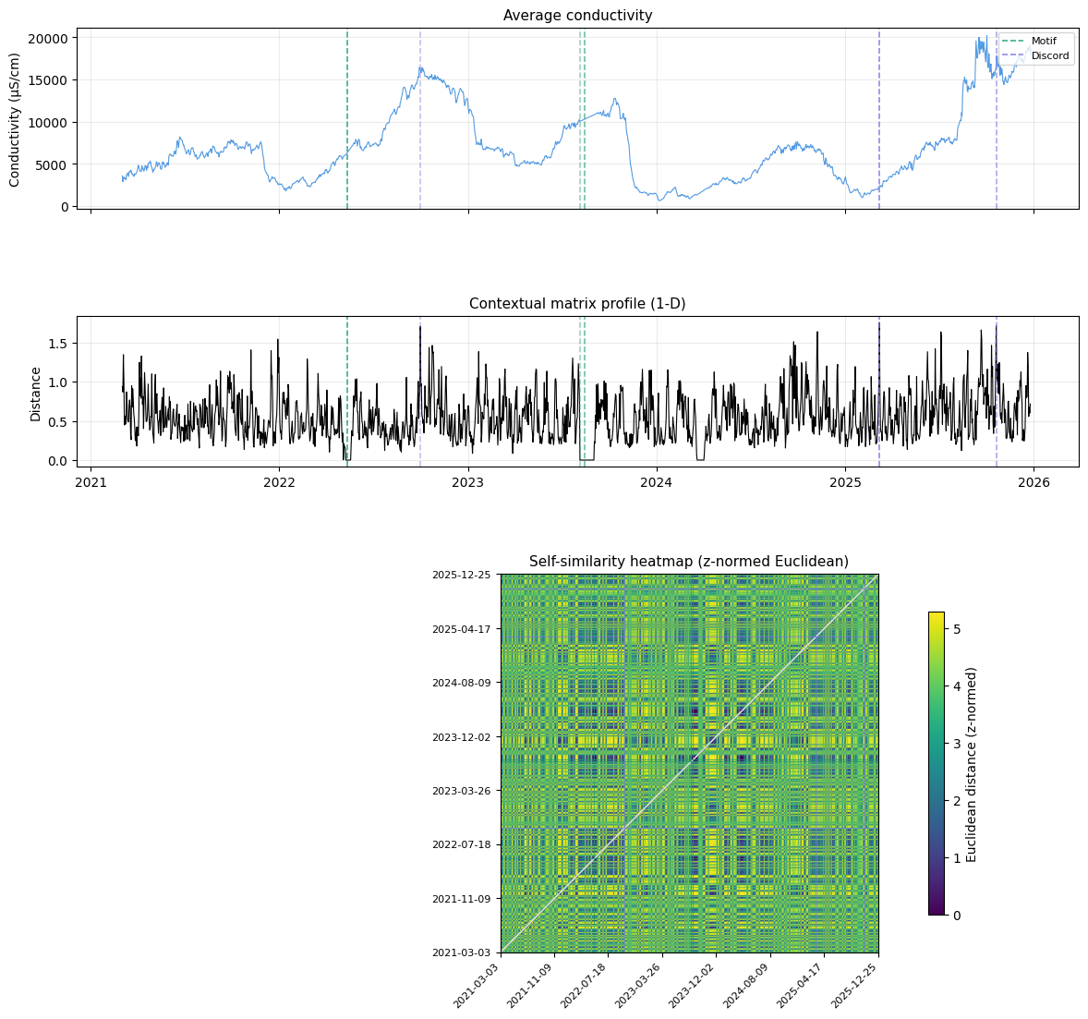
The conductivity signal moves in large, slow multi-month arcs (peaks in winter/spring, troughs in summer), while precipitation is random and spiky. Individual rain events don't seem to cause immediate drops in conductivity. This suggests the dominant driver is probably seasonal freshwater discharge from rivers or tidal/saltwater intrusion, not local rainfall.
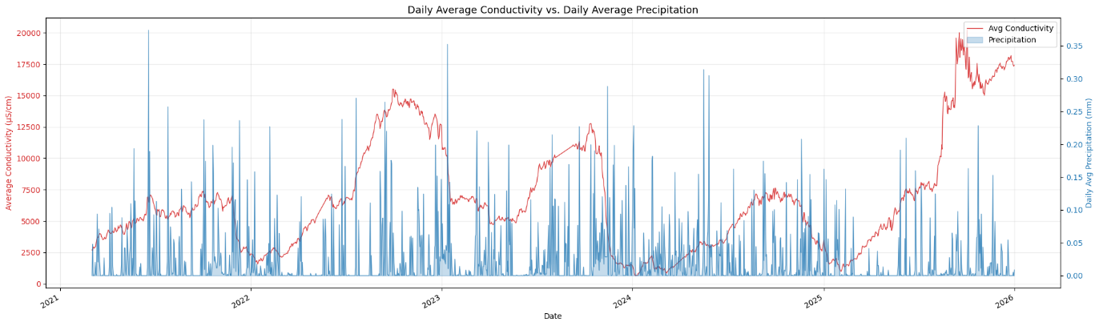
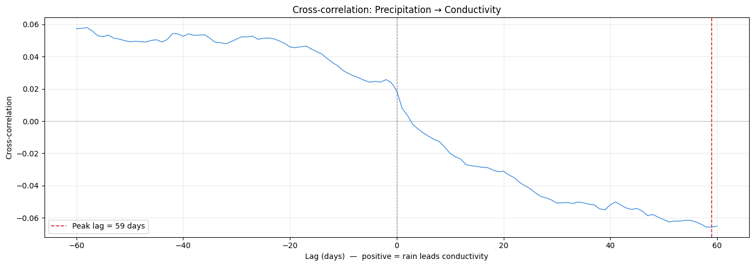
Take away:
- A repeating seasonal cycle
- A long-term upward trend in conductivity

